Case Report

Avulsion tibial tubercle fracture, resulting from a low energy trauma

Malkidou Nymfodora¹, Galanis Vasilios², Fiska Aliki¹
¹ Laboratory of Anatomy, Medical School, Democritus University of Thrace, Greece
² Orthopaedic Clinic, Didymoteichon Hospital, Greece

Abstract
This study aims to describe a rare tibial tubercle fracture (TTF) in an adolescent boy, associated with complete patellar ligament avulsion, resulting from low energy trauma. A 13-year-old boy, while walking home from school, experienced an abrupt twisting calf movement that injured his knee causing him to fell to the ground. Radiological examination revealed a TTF combined with high-riding patella. The fracture was promptly fixed with cannulated screws and transosseous sutures. A combined TTF and patellar ligament avulsion during mild activity in a healthy young individual is considered a rare phenomenon, and requires the same specialized surgical intervention as high-energy fractures, to avoid serious motion impairment.
Keywords: Adolescent knee trauma, high riding patella, patellar ligament avulsion, tibial tuberosity fracture

Corresponding Author: Malkidou Nymfodora, Anatomy Laboratory, Medical School, Democritus University of Thrace, Greece, mob:+306957606036, nmalkidou@gmail.com

Introduction
Avulsion fractures of the tibial tubercle (TTF) are rare and constitute less than 1% of all physeal injuries.¹ They mostly affect teenage boys, who are usually more energetic and competitive than girls and whose skeletons have not yet completed their growth at that young age. Typically, they occur during athletic activities, since physis undergoing developmental changes is more vulnerable to excessive loads exerted on it during sports.²⁻⁶
Reports on tibial tubercle fractures associate them with different levels of patellar ligament avulsion, that can be partial or complete. All cases presenting TTFs with simultaneous patellar ligament avulsion are attributed to high energy activity.³⁻⁴
To our knowledge, TTF cases with complete patellar ligament avulsion resulting from low-energy trauma are absent from the medical literature. How can mild physical activity of a young healthy male result in such a severe lesion?

Methods and Materials
A 13-year-old male with no medical history sustained an injury to his left knee, during his walk home from school after a sudden twist of his knee joint. He fell onto the ground and felt acute pain in his sprained knee. When trying to get up, he realized he could not use his injured leg or put any weight on it at all.
Physical examination revealed a sprained left radiocarpal joint and a large soft tissue swelling on the lower thigh, over the left knee. Palpation caused extreme tenderness, while the knee’s range of motion was strongly reduced. Radiology demonstrated the TTF. The detachment of the patellar ligament from its insertion site caused the proximal displacement of the quadriceps muscle and the uplifting of the patella towards the hip: a typical demonstration of high-riding patella.(Figure 1) Fragments of the fractured tibial tubercle were attached to the edge of the patellar ligament.
The fracture was classified as type IIB according to Ogden classification due to the comminution of the tibial tubercle.⁵

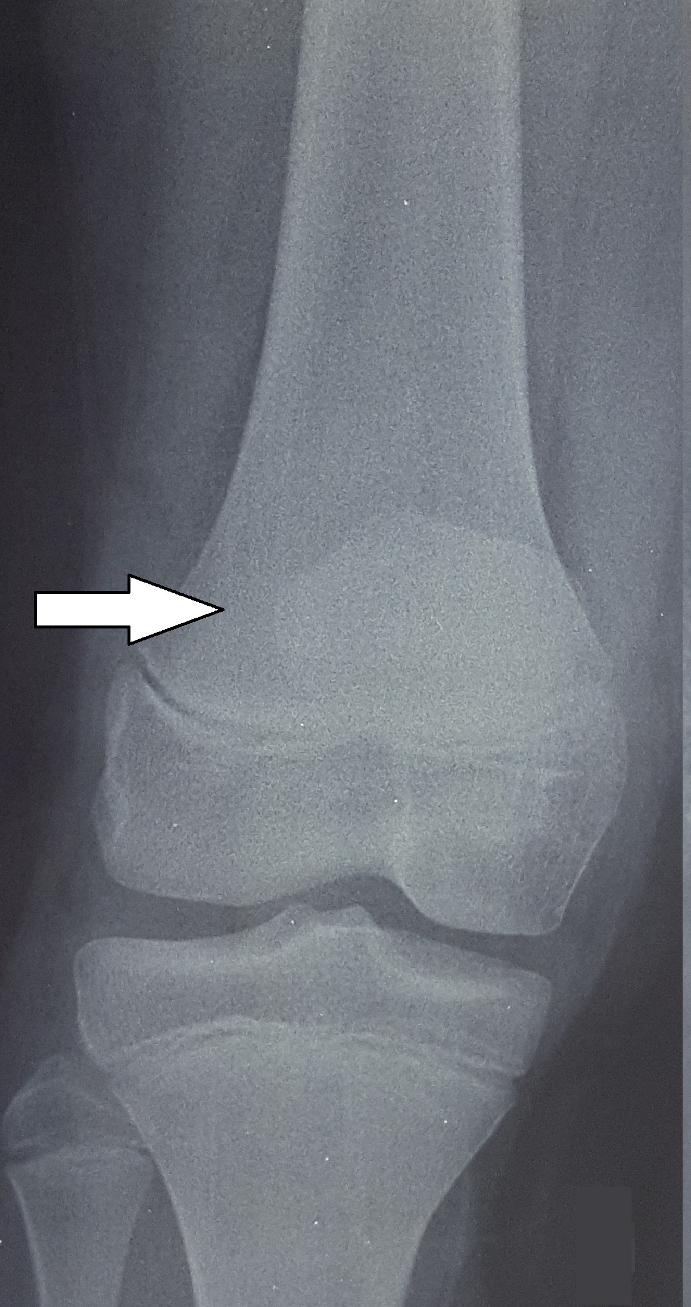 | Figure 1. A. High riding patella (AP left knee radiograph) and B. High riding patella with avulsion tibial tubercle fracture (white arrow) (lateral left knee radiograph)

The knee operation was scheduled within the next 8 hours. A 5 cm long longitudinal midline incision, was made over the area of the anterior tibial plateau, revealing that the patellar ligament was completely torn and separated from its attachment point and the tubercle fragment was comminuted and displaced proximally.(Figure 2) Hemarthrosis was also present. With the use of C-arm fluoroscopy, the displaced TTF was fixed with two 4.0mm cannulated screws. Τhe patellar tendon extensions around the tibial tubercle were additionally fixed with transosseous sutures (synthetic absorbable sutures, PDS 2). A long-leg cylindrical cast was placed on the boy’s leg for 4 weeks. The fracture healing was confirmed by radiology 12 weeks after surgery.(Figure 3)

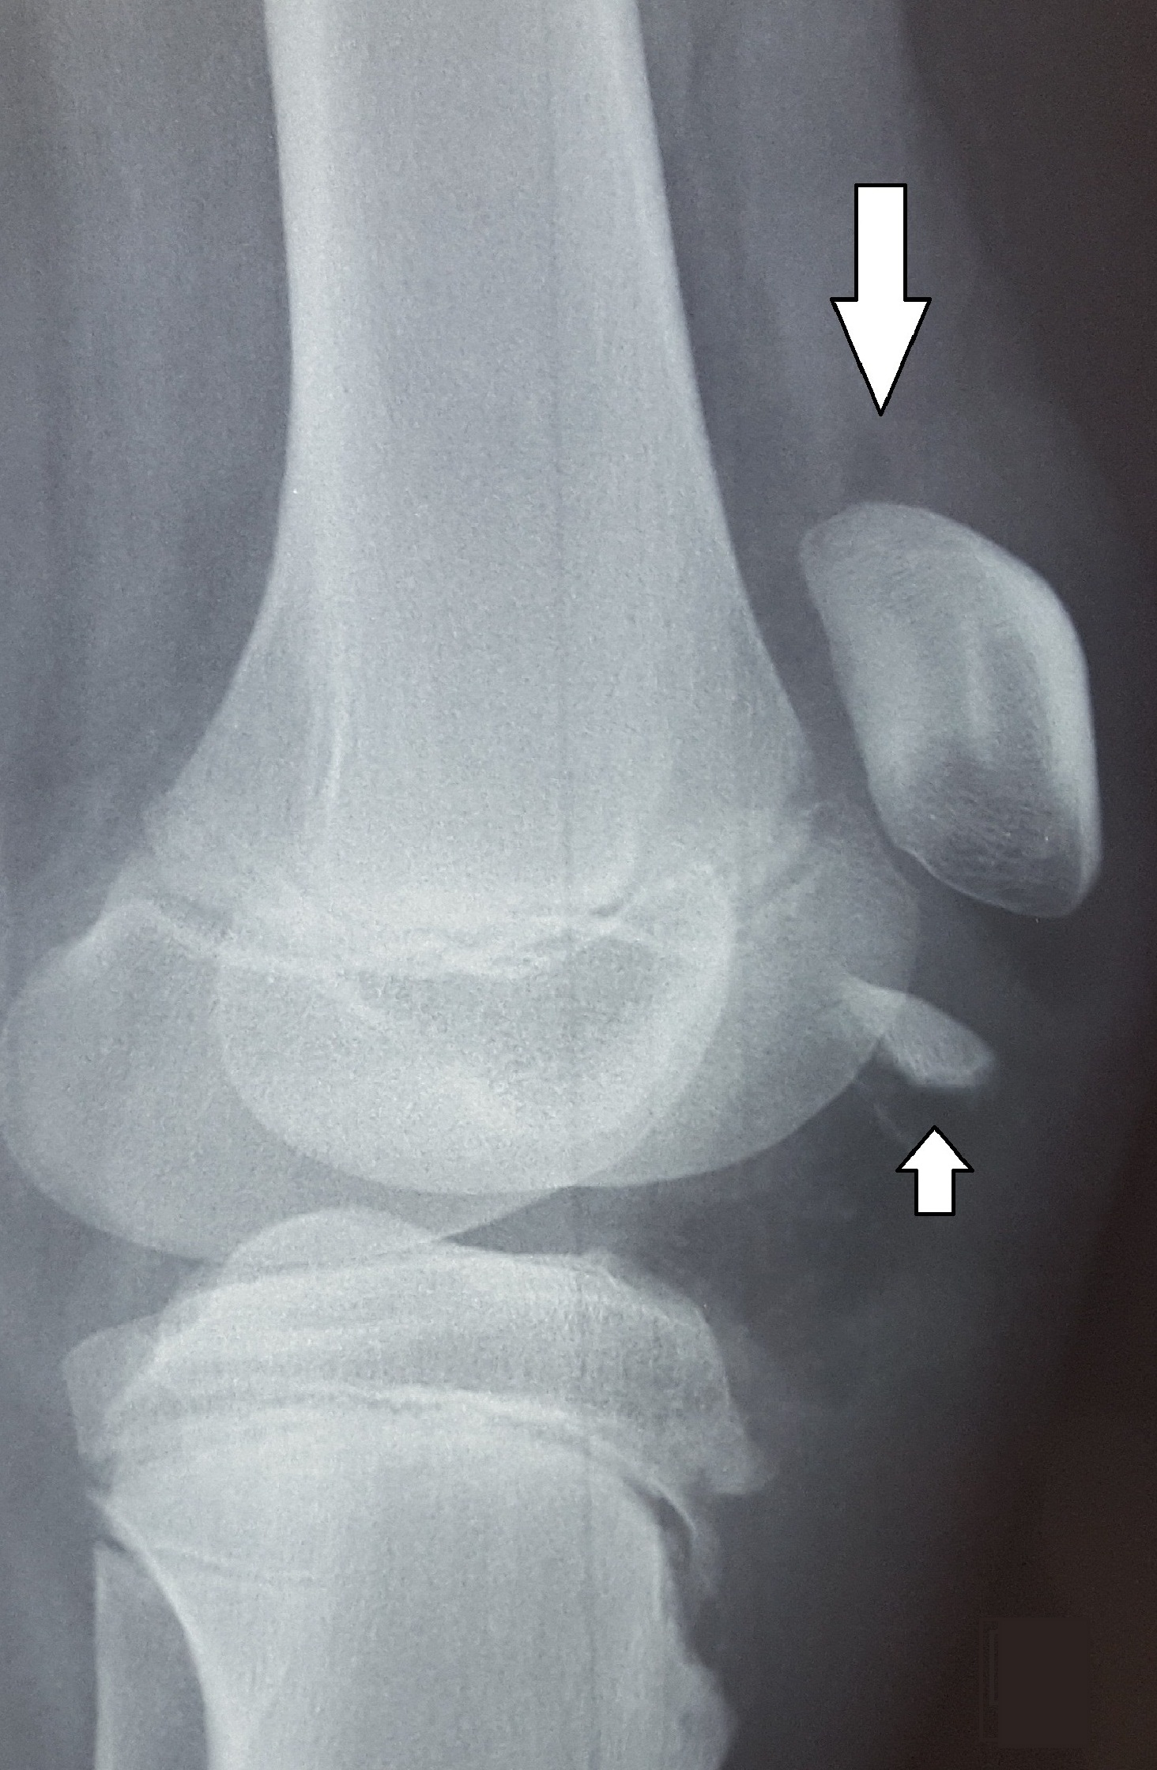 | 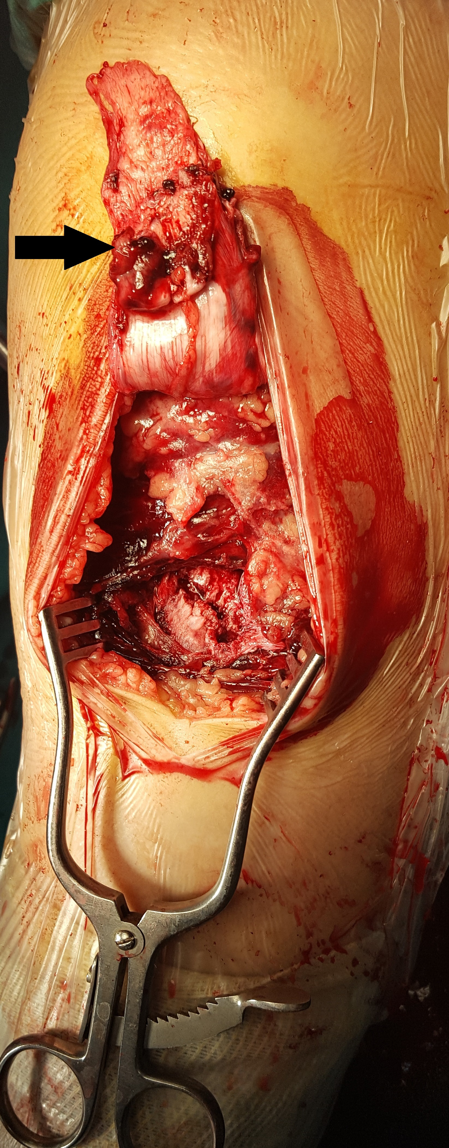
Figure 2. Raised patella and patellar ligament, with a fragment of the tibial tubercle (arrow) attached to its edge (intraoperative photograph) | Figure 3. Osteosynthesis of TTF. A. AP and B. lateral radiograph of the left knee, 8 weeks after surgery

Physical therapy was implemented to restore knee movement. The extension mechanism of the injured knee progressively improved, and the patient had complete recovery of the range of motion. Osteosynthesis material was removed 12 months after the operation.(Figure 4) The one-year follow-up confirmed full range of motion and no muscle atrophy, which enabled the boy’s full return to high-impact activities.

Discussion
Avulsion TTF is a well-described injury in adolescent athletes, with an average onset age of 14.6 years old (range 13-16y).² Our case adds an innovative injury mechanism, namely low-energy trauma, to the very few published cases of tibial tubercle fractures with simultaneous patellar ligament avulsion.
Mayba in 1982, was the first to describe TTF with complete patellar ligament avulsion due to high-energy trauma.⁴ Several studies noted that the most common mechanism was, in fact, high-energy jumping.⁶ Sports and gym training put additional stress on bones and muscles. Young people participating in such activities, which especially involve running and jumping, have an increased risk of TTFs.² Violent active knee flexion against a tight quadriceps contraction (e.g. landing from a jump), or a violent quadriceps contraction against a fixed foot (e.g. jumping) are the usual causes of TTF.⁶.
Documented causative factors for the patellar tendon avulsion as well as for TTF in adolescents include osteogenesis imperfect and Osgood- Schlatter disease, which often appears during puberty when bones, muscles, and tendons are growing at different rates.^{7,9}
In our case the patient did not have any pre-existing radiographic or clinical signs of bone disease, and his injury was not the result of sports activity. TTF occurred after a rapid passive flexion and rotation of the knee against the contracting quadriceps: the boy was injured when he lost his balance while walking. It is astonishing how stumbling during a walk can cause such a severe injury to a young patient with no medical history.
We applied the Watson-Jones classification of TTFs, modified by Ogden according to the level of displacement and comminution of the fragment and found it to be type IIB.⁶ In medical literature, type III TTFs are widely studied, while on the other hand a type II TTF with complete patellar tendon avulsion, resulting from low-energy trauma is an extraordinary phenomenon. Furthermore, a displaced avulsion of the entire ossification center of the tibial tubercle (usually ossified between 7 and 9 years of age) with comminution, imposed on a healthy 13-year-old patient should be considered as a medical rarity.^{2,3,4,8,9}

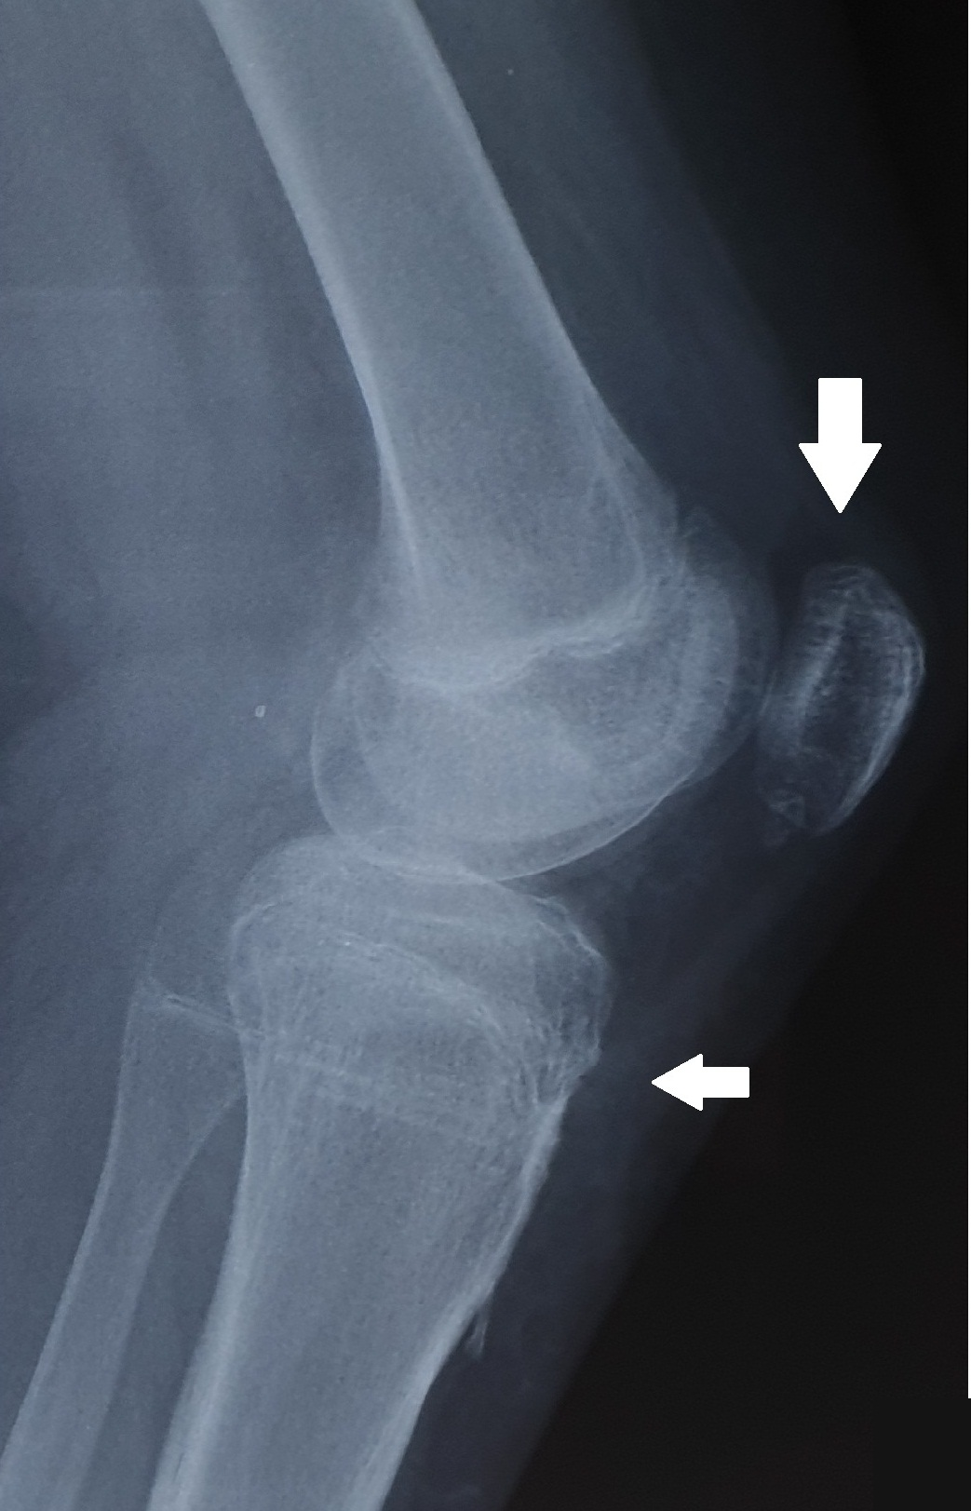 | Figure 4. Healed fracture after the removal of the osteosynthesis material, 1 year postoperatively. A. AP and B. lateral left knee radiograph

Surgery to treat TTFs is reserved for cases with comminution of the tibial tubercle. The immobilization period usually lasts between 3 and 6 weeks, after which the range of motion is gradually restored.^{2,3,4,7} Our case received the same surgical treatment, followed by leg immobilization within the suggested time limits and resulted in full recovery of knee function. We, therefore, suggest that type IIB TTF combined with patellar ligament avulsion should be treated with specialized open surgery for TTF repair to avoid grave consequences in the patient’s quality of life.
It seems that low energy activity in adolescents, even in cases having no additional risk factors, can traumatize the knee joint more severely than is reported in the literature.

Conflicts of Interest Statement
The Authors declare that there is no conflict of interest.

Funding/Support Statement
The Authors declare that there is no funding/support statement.

References
1. Hamilton SW, Gibson PH: Simultaneous bilateral avulsion fractures of the tibial tuberosity in adolescence: A case report and review of over 50 years of literature. Knee. 2006, 13:404-407.
2. Pretell-Mazzini J, Kelly DM, Sawyer JR, Esteban EM, Spence DD, Warner WC Jr, Beaty JH: Outcomes and Complications of Tibial Tubercle Fractures in Pediatric Patients: A Systematic Review of the Literature. J Pediatr Orthop. 2016, 36:440-6.
3. Yousef MAA: Combined avulsion fracture of the tibial tubercle and patellar tendon rupture in pediatric population: case series and review of literature. Eur J Orthop Surg Traumatol. 2018, 28:317-323.
4. Mayba II: Avulsion fracture of the tibial tubercle apophysis with avulsion of patellar ligament. J Pediatr Orthop. 1982, 2:303-5.
5. Ogden JA, Tross RB, Murphy MJ: Fractures of the tibial tuberosity in adolescents. J Bone Joint Surg Am. 1980, 62:205-215.
6. Mirbey J, Besancenot J, Chambers RT, Durey A, Vichard P: Avulsion fractures of the tibial tuberosity in the adolescent athlete. Risk factors, mechanism of injury, and treatment. Am J Sports Med. 1988, 16:336-40.
7. Yousef MAA, Rosenfeld S: Acute traumatic rupture of the patellar tendon in pediatric population: Case series and review of the literature. Injury. 2017, 48:2515-2521.
8. Capogna B, Strauss E, Konda S, Dayan A, Alaia M: Distal patellar tendon avulsion in association with high-energy knee trauma: A case series and review of the literature. Knee. 2017, 24:468-476.
9. Carius B. M., Long B. Osgood-Schlatter Disease as a Possible Cause of Tibial Tuberosity Avulsion. Cureus, 13(2)

